Static Routing and Switch VLAN 1 Configuration

Overview
For all their functionality and power, routers really don’t know very much. Properly configured, all a router knows is directly connected interfaces and where to go if traffic is not on the connected interfaces networks. As a network technician, it is your responsibility to “teach” routers how to reach desired networks. You do this by configuring routes on each router to help the packets along to their final destinations and back. Depending on the topology, you may be able to make this process easier with the configuration of default routes. Another element tested this week is your ability to configure switches for remote management by putting an IP address on VLAN 1 and configuring a default gateway. This project will also reinforce the topics in last week’s project by having you configure DHCP pools, IP Helper Addresses, and host A records on the DNS server.

This project uses a starting template for Packet Tracer (Static_Routing_Student_Project.pkt). It is in your best interest to do some planning prior to actual configuration. Decide where default routes can save you some configuration work. The simulation mode in packet tracer and tracert (and trace route) can help troubleshoot routing issues.

Outcomes
- In this project, you will demonstrate how to configure static routes in a multi-router environment.
- You will also learn how to add remote management capability to switches by configuring VLAN 1 and default gateways.
- You will also demonstrate the steps required to add DHCP and DNS capability to a network.

Scenario
In the staff meeting yesterday, you discussed the final infrastructure in the main office. The network administrator built the topology into network simulation software (Packet Tracer).

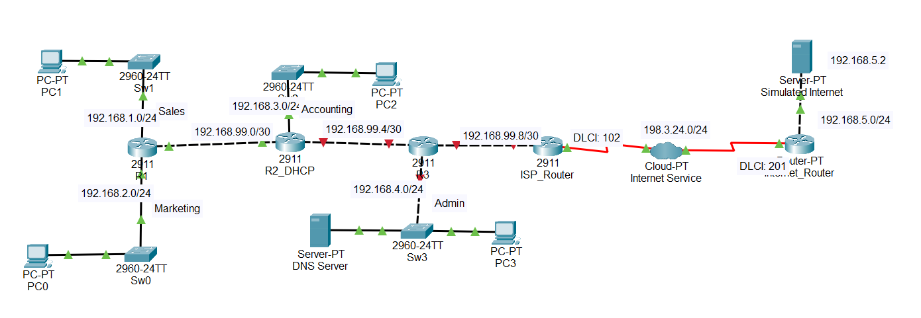

You have been tasked with the configuration of required items. Among these are:
- Configure static and default routes to support all subnets
- Create DHCP pools to assign ip addresses to all PCs.
- Create DNS records for all routers, switches, and the DNS Server

Instructions
- Open the following file:
  - Static_Routing_Student_Project.pkt
- Rename the file as follows:
  - fLast_Static_Routing_Student_Project.pkt
  - For example, if your name were Bob Smith, you would name the file as follows:
    - bSmith_Static_Routing_Student_Project.pkt
- Carefully review the Notes section before continuing.
- Open the Static Routing - Worksheet.docx and record your work as indicated.
- Save the worksheet.
- When done, submit your Packet Tracer file and completed worksheet through the submission link.

Notes
- The network had been properly cabled, hostnames configured on the routers, and passwords removed. For this project, you are welcome to work directly in the CLI page of the devices. If you decide to change hostnames, configure passwords, or add telnet capability, please document your changes.
- All router interfaces have been configured with appropriate network addresses. You will address router interfaces in next week’s project.
- The networks are all labeled on the Logical View in Packet Tracer. You will need to examine each router to determine the actual interface addresses.
- The interfaces on R3 have all been shut down and must be enabled prior to working on the project.
- A DHCP pool has been created on the R2_DHCP Router for Sales. You will need to build the rest of the pools (Marketing, Accounting, Admin) and configure IP Helper Addresses where necessary.
- DNS has been enabled on the DNS Server but no “A” records have been added.
- Routing has not been configured on any router except for the ISP Router which has a route to and from the Simulated Internet

